Problem Definition:
n points are given in the 2D plane. All of these points must be visited in some order and return to the initial node. This is called the travelling salesman problem or TSP in short. The following problems must be solved:
1. Exact Exponential Method: All possible permutation must be generated to find the hamiltonian cycle with the least cost. This is the Brute Force approach.
2. Branch and bounding Method: A partial tour [a,{S},b] consists of an from a to S, from S to b and between a and b. if S equals V-{a,b} then this finds a hamiltonian cycle. The shortest such cycle is a solution to the TSP problem. A lower bound for each such cycle is given by:
1. The lightest edge from a to V − S.
2. The lightest edge from b to V − S.
3. The minimum spanning tree of V − S.
Their sum gives a lower bound, B. If a branch has B greater than the current shortest cycle, that branch can be pruned.
3. Greedy 2-Approximation Algorithm: This is only an approximation algorithm, meaning there is a chance that the optimal solution can not be obtained. Here an MST is constructed on all the n points. Then an inorder traversal takes place. Whenever a vertex is revisited through some edge, that edge is discarded and replaced with a new edge to the next unvisited vertex.
Complexity Analysis:
1. Exact Exponential Method: As (n-1)! Cases must be generated, this has a time complexity of Omega(2^n)
2. Branch and bounding Method: This has a Best case Time complexity of O((n^3)log(n)) due to running MST on each subgraph obtained through minimal separation and worst case of Omega(2^n)
3. Greedy 2-Approximation Algorithm: This has a time complexity of O((n^2)log(n)) due to the time complexity of MST of O((n^2)log(n)).
Test Case Design:
All collinear points:
Time complexity of O(n) to find if all points are collinear.
Test1:
2 0
2 3
2 4
2 5
ANS: No solution possible (.005s)
Test2:
0 0
1 1
2 2
3 3
ANS: No solution possible (.005s)
Different Random Cases:
Every test case with only two points will give a no solution result. So, we start with size 3.
Test3:
3.24674264321 3.38316277845
4.41094284878 1.87393503342
2.31770290888 1.97496944339
Ans:
Cost for TSP : 5.6888 (.008s)
Approximate Cost for TSP : 5.6888 (.008s)
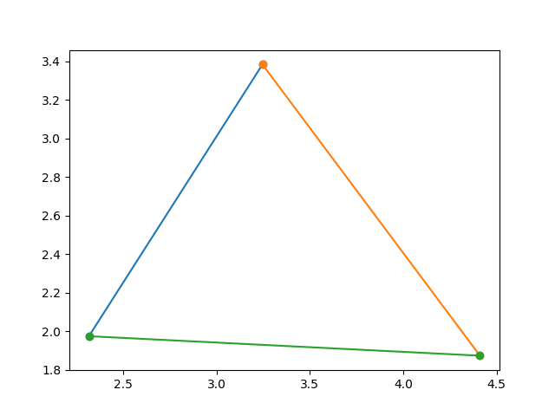
Test4:
3.14765818694 0.587031630672
4.45222967954 3.12049819163
0.710205998923 1.4851511672
4.56946989079 3.92668769503
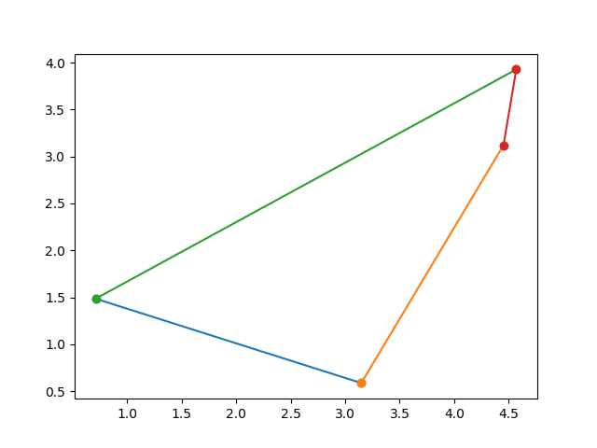
Ans:
Cost for TSP : 10.828 (.007s)
Approximate Cost for TSP : 10.828 (.004s)
Test5:
1.07936473554 1.27342198991
0.0958531422976 2.13455596727
3.04408001035 0.494166133512
4.00468550244 0.275926853134
2.19106327907 1.7621540283
Ans:
Cost for TSP : 8.87877 (.003s)
Approximate Cost for TSP : 9.03928 (.005s)
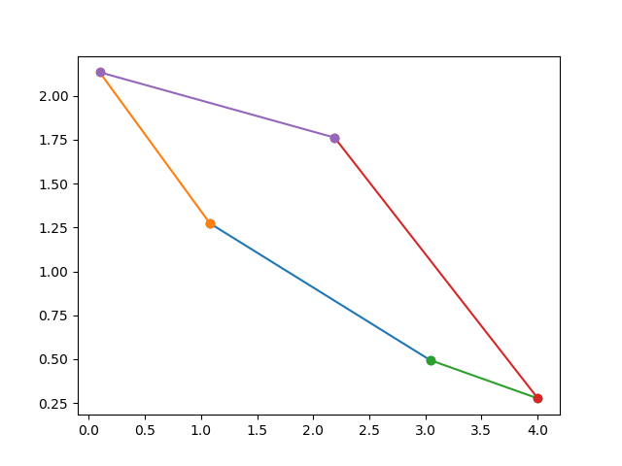
Test6:
2.87345788015 2.46117418225
4.27903447802 2.33158628626
1.18161774204 1.47799521133
3.0752772565 1.75438444277
1.9689328702 0.0378557652473
2.45733754115 4.0641335146
Ans:
Cost for TSP : 10.9698 (.013s)
Approximate Cost for TSP : 12.355 (.004s)
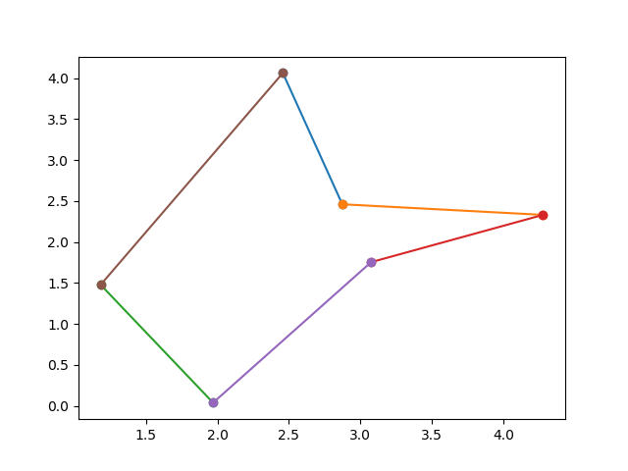
Test7:
4.72026506756 1.52948783084
3.01279914075 3.7941934093
0.103903516179 0.65837140461
4.91363799494 2.60888525204
4.28488490032 3.25666775098
3.80424993864 4.0748955071
2.21327661312 4.28251427049
Ans:
Cost for TSP : 13.616 (.05s)
Approximate Cost for TSP : 17.2398 (.004s)
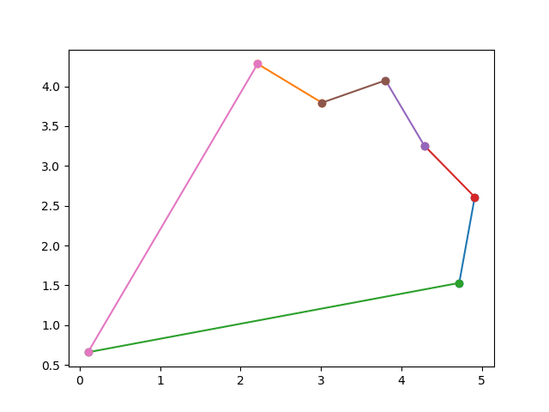
Test8:
2 0
2 3
2 4
2 5
0 0
1 1
2 2
3 3
Ans:
Cost for TSP : 13.2268 (.016s)
Approximate Cost for TSP : 14.0552 (.004)
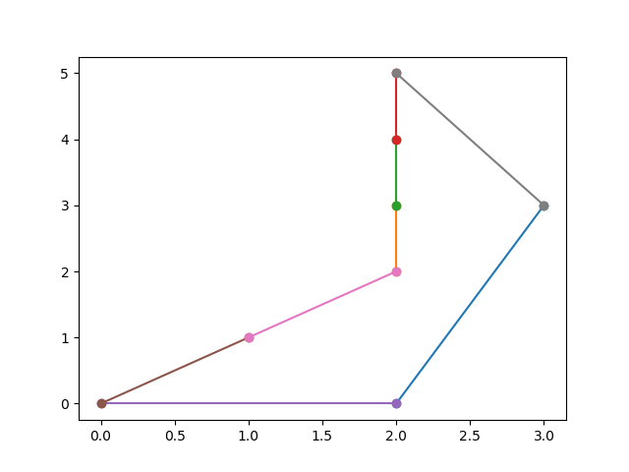
Test9:
4.59783759631 4.67455506061
3.15658139981 0.0445347649515
0.29139742219 2.9900623671
4.67220601605 3.31107826089
0.876957629082 1.17540369384
0.976566538568 2.82899091674
2.54593687726 4.32833440284
1.48654100897 0.00347629317873
3.55207093883 2.25513231922
Ans:
Cost for TSP : 15.0041 (.025s)
Approximate Cost for TSP : 15.0041 (.008s)
